Activity Diagrams

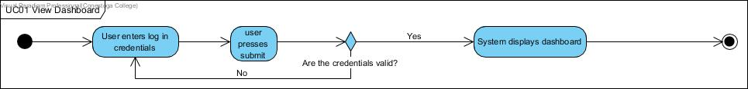

Figure 1- UC01 View Dashboard

Note\* as Dispatcher login is handled by Circumference, our project will immediately start on the Dispatcher’s dashboard

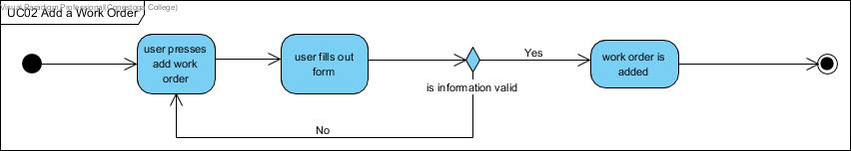

Figure 2 - UC02 Add a Work Order

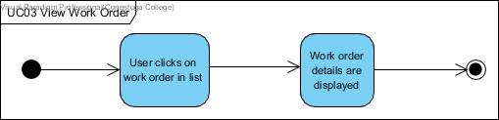

Figure 3 - UC03 View Work Order

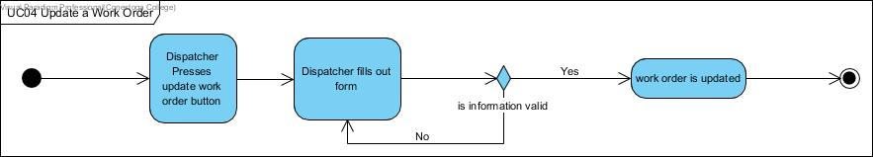

Figure 4 - UC04 Update a Work Order

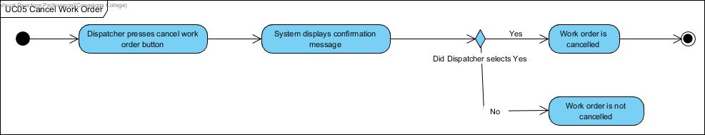

Figure 5 - UC05 Cancel a Work Order

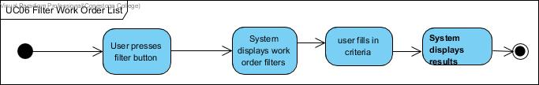

Figure 6 - UC6 Filter Work Order List



Figure 7 - UC07 Search for a Work Order

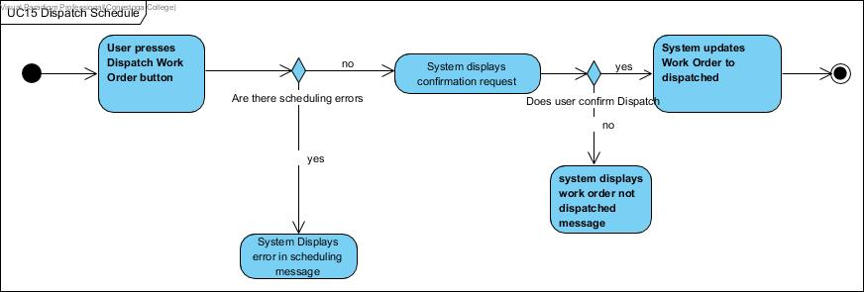

Figure 8 - UC15 Dispatch Schedule

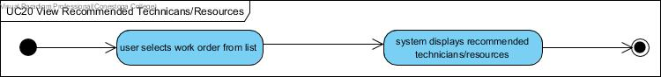

Figure 9 - UC20 View Recommended Technicians/Resources

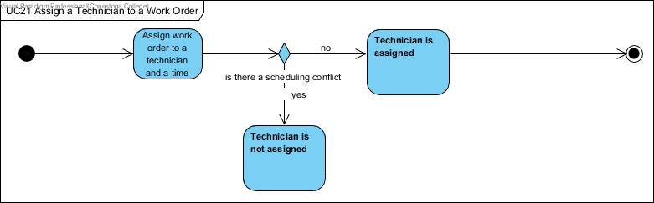

Figure 10 - UC21 Assign a Technician to Work Order

Note\* This use case was added for testing purposes as assignment of technicians to work orders is fulfilled in the Gantt chart in iteration 2.

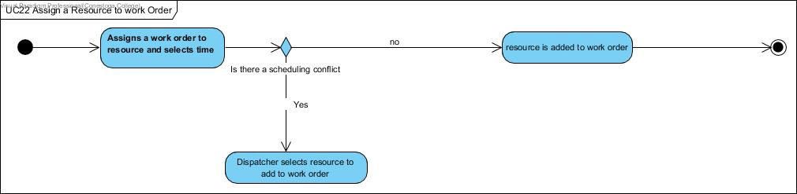

Figure 11 - UC22 Assign a Resource to Work Order

Note\* This use case was added for testing purposes as assignment of resources to work orders is fulfilled in the Gantt chart in iteration 2.